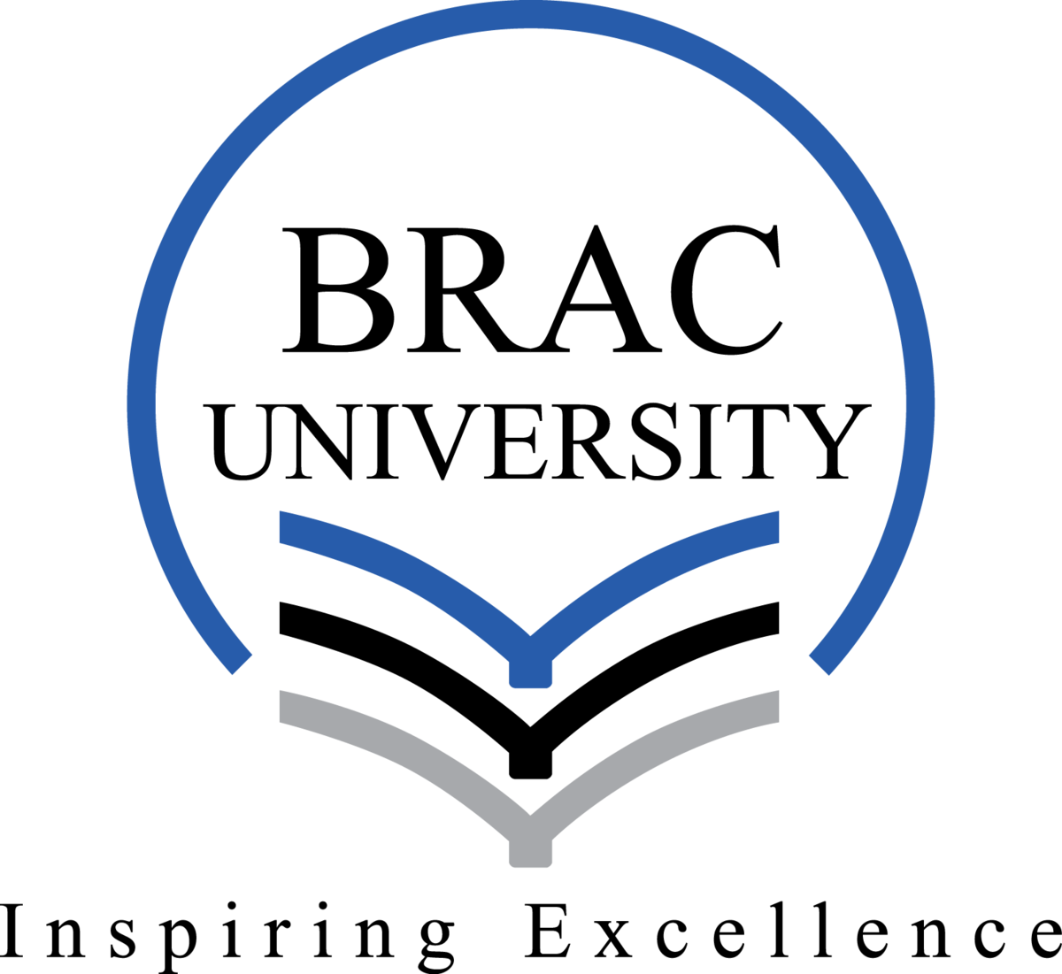

Name of the Student: Mehedi Hasan Rowdro
ID: 24101226
Semester: Fall2024
Section: 01

HUM103 Fina Project

For our HUM103 final project, Group B worked on the topic “Utilitarianism (Quality, Quantity, Act, and Rule).” We decided to create a short film to explain this philosophy in an easy way. My role in the project was as the second lead. I played a character who helped a girl named Israt deal with her pain after being cheated on by someone she loved and trusted.

In the story, my character was in the same section as Israt, and in a short period we became close friends. When I learned about her struggles, I tried my best to help her feel better. I explained to her that life is not just about lovelife. I encouraged her to focus on other important relationships, like family and friends. So that, she could find support and happiness there. To make her feel better, I introduced her to a new friend circle. This group made her feel included, supported, and happy again. Spending time with them made it easier for Israt to move past her trauma and enjoy life more. Slowly, she finally started healing and felt like herself again.

Honestly, it really taught me about how such little things can make a huge the difference in someone's life. This made me understand exactly how utilitarianism works in real life. Which’s theme is bring the most happiness to the most people. Working on this short film was a great experience because it was fun and meaningful at the same time. Through teamwork and creativity, we were able to share an important message about helping others and finding happiness.

